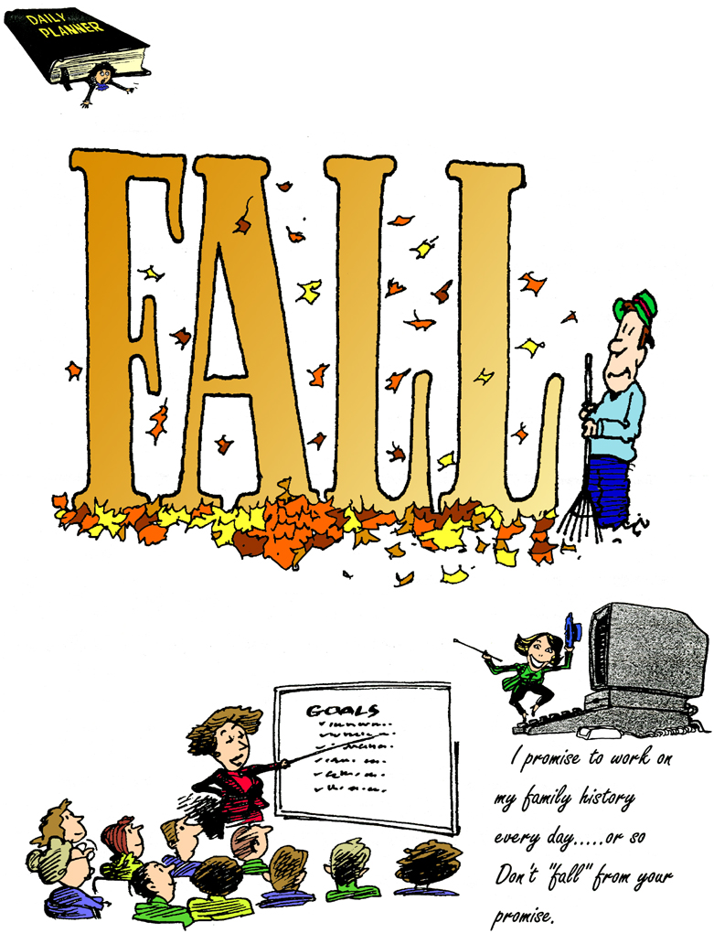

Indexers Are The Genealogist’s Best Friends

HSGS Web Site. <www.rootsweb.com/~usgenweb/mi/iosco/3501hsgs.htm> is the address for our HSGS's indexes on the Internet. The search engine for this site, or all of Michigan or any of the other Michigan’s counties is www.rootsweb.com/~usgenweb/mi/search.htm. We currently have 1,123 indexes, 27,282 printed pages, and 1,203,978 name citations indexed: If indexes were printed out they would be 9 feet tall and weight 284 pounds. All these files are on HSGS’s master file on our computer’s external drive, & the CD we sell, but only about 94% are on the web site (does not include new indexes within the last month, draft indexes not yet finished, & a some random data corrections). The status of our master indexes & CD follows:

Master Index Status | Oct | Nov | Dec | Feb | Mar | Apr | May | Jun | Jul | Aug
On the web, current | 871 | 877 | 891 | 904 | 928 | 979 | 994 | 1009 | 1021 | 1057
On the web, out dated | 54 | 54 | 54 | 54 | 54 | 31 | 30 | 30 | 30 | 30
New, not sent to web | 5 | 13 | 13 | 20 | 24 | 16 | 7 | 11 | 13 | 6
Future, being edited | 7 | 7 | 7 | 7 | 7 | 7 | 7 | 7 | 7 | 7
Future, partially done | 36 | 36 | 36 | 37 | 38 | 38 | 38 | 23 | 22 | 23
Totals | 973 | 987 | 1001 | 1022 | 1051 | 1071 | 1076 | 1080 | 1093 | 1123

HSGS member and Vice-president Dan Stock is HSGS’s Web Master and places our indexes directly on our USGENWEB web site.

New Indexes Added This Month:
- Index to Herald: Jan 1933; Oct, Nov & Dec 1943. By Joan Doerr of Gettysburg PA.
- Index to News: 1987 Jan-Jul. By Charles Birnbaum of Tawas City MI.
- Index to Tawas Township 1857-2007. By Alonzo J Sherman of Oscoda MI.

New HSGS Books added This Month:
- Carol Adams of East Tawas MI donated the following:
Local | Title | Date
IOS | Sawdust Days, 1974 | 1812+
IOS | Story of the Life of Edwin August Rehil, 1977 | 1879+
KY | The Kentucky Land Grants Vol 1 Part 1, 1971 | 1782-1924
KY | The Kentucky Land Grants Vol 1 Part 2, 1971 | 1782-1924
KY | Two Counties in Elizabethtown & Hardin County KY, 1979 | 1776-1976
KY | First Census of KY, 1976 | 1790
KY | The McCoys: Their Story, 1976 | 1900+
KY | Pulaski Co KY Records #1: Marriages 1799-1850, 1977 | 1799-1850
MD | Maryland Marriages, 1978 | 1634-1777
NJ | Index to Military Men of NJ, 1977 | 1775-1814
NJ | Genealogy of Early Settlers in Trenton & Ewing, “Old Hunterdon County,” 1883 | 1939+
OGE | Atlas & Plat Book Ogemaw Co MI, 1972 | 1972
OGE | Ogemaw Co Plant Maps- First Land Owners, 1978 | ?
OH | History of Coshocton Co OH, 1881 | 1740-1881
OH | Hill & Allied Families, 1974 | 1760+
OH | Stories of Guernsey County, OH, 1943 | 1776-1976
OH | History of Knox County OH, 1976 | 1876-1976
OH | Pioneer Marriages of Guernsey Co OH, 1964 | 1810-1830
OH | Clinton Co OH Newspapers Death & Obituary Abstracts, 1973 | 1838-1867
OH | Deaths- Coshocton Co OH, 1976 | 1867-1909
OH | Clinton Co OH Obituaries & Selected Genealogical Notes, 1976 | 1867-1875
TN | Marriage Record of Washington County TN | 1787-1840
TN | Tennessee Genealogical Records: Records of Early Settlers from State & County Archives, 1980 | 1776
USA | Directory of Historical Societies & Agencies in the US & Canada, 12th Ed, 1982 | 1982
USA | Index to Revolutionary War Pension Applications in the National Archives, 1976 | 1800-1900
USA | Encyclopedia of Local History and Genealogy, Series 1 Vol 1, 1977
USA | DAR Patriot Index, 3rd supp, 1976 | 1774+
USA | DAR Patriot Index, 2^{2nd}supp, 1973 | 1774+
USA | DAR Patriot Index, 1st supp, 1969 | 1774+
USA | Listing of Historical Articles in DAR Magazine, 1970 | 1892-1970
USA | DAR Patriot Index, 1966 | 1774+
USA | The Manual of Heraldry, 1929 | 1300+
USA | The Genealogical Helper (in Binder) | 1978-1978
USA | The Genealogical Helper (in Binder) | 1982-1978
VA | Virginia Tax Payers, 1940 | 1782+
VA | The Quit Rents of Virginia | 1704+
VA | Virginia Wills & Administrations, 1985 | 1632-1800
VA | Early Settlers of Lee Co VA & Adjacent Counties, Vol 1, 1977 | 1492+
VA | Early Settlers of Lee Co VA & Adjacent Counties, Vol 2, 1977 | 1492+
VA | The Virginia Dynasties, 1969 | ?

New Books at the Parks Library:
- Public Records Online- The National Guide to Private & Government Online Sources of Public Records, by Facts On Demand Press, 6th Edition, © 2006. (352.3/Pu).
- The Mighty Rifle River- the headwaters of Arenac County and Surrounding Areas of Northern Michigan, by John E Cuthbertson, © 2007. (Ref/977.471/Cu).
- StJohns United Church of Christ, AuGres Michigan, 1912-1981, by Arenac County Historial Society, ©2005. (Ref/977.4774/St).
- Sixteenth Annual Celebration of the Arenac County Pioneer Society, At AuGres Michigan Saturday, August 26 1911. (Ref/977.4774/Ar).
- The Early AuGres Area- a series of Maps showing Buildings & Landmarks, edited & modified by Mike Merlvin, 2006. (Ref/977.4774/Ea).
- Whittemore Michigan 1907-2007, by Lugene Daniels, ©2007, (Ref/977.474/Da).
- Memoirs: Sesquicentennial Tawas Township 1857-2007, by Naomi Stonehouse, ©2007 (Folder-His-3)

HSGS’s Treasurers Report (July 31 2007). Savings $1,248.02, Checking $608.02, cash $2.00, = Total $1,858.04.

Glass Negatives. The joint agreement HSGS had with the Iosco County Historical Society to scan their glass negative file has been canceled by them. They have a new president and are seeing things in a new way.

Free Computer Class. Parks Public Library will give a 6 week class titled “Basic Computer Training For Senior Citizens.” It will be at the Library on Wednesdays from October 3rd through November 7th at 8:15am – 9am. It is limited to 6 persons.

Ancestry Library Edition. The Library of Michigan will no longer be funding Ancestry at Public Libraries after this Fiscal Year [October), due to budget constraints. They are switching to Heritage Quest. Ancestry will still be available at the Library of Michigan in Lansing. (MI Gen Council Meeting July 12 2007).

Reading HSGS News Letters on the Web. Our newsletters are now in both MSWord and PDF formats. If you still have difficulty opening the newsletter files, realize it may take a long time to open, sometimes 45-60 seconds for MS-Word but usually less time for PDF. If this is not the problem, then down load the free software called “Word Viewer 2003,” it is available at <www.microsoft.com/downloads> and then link to this specific software.

Word Viewer 2003 allows you to view, print and copy any MS-Word document, even if you do not have Word installed. However, you cannot edit the document. This replaces all previous Word Viewers.

This program allows you to open all Word documents created by both Microsoft for Windows and for MacIntosh. Beside Word documents it will also open the following formats: Text, Rich Text, Web page formats (htm, html, mht, mhtml), WordPerfect 5.x and 6.x, Works 6.0 and 7.0, and XML.

Appreciate anyone having trouble opening our newsletter tell us their problem. And, how they have solved their problem.

Local Authors to give a Talk about Writing and Publishing of local History and Genealogy. The talk will be August 25th 10-12am at the Tawas City Library and the same talk at 7-9pm at the A Different Blend Coffee Shop in East Tawas. Of the six speakers four are HSGS members: Naomi Stonehouse, Lugene Daniels, Judy Sheldon, and Alonzo Sherman. The other persons are Betty Fahselt-Senter and John Cutherbertson.

TRAINING AVAILABLE (One Time Events):

Year/Mo/Day | Description/Location/Contact
2007/09/29  Sat | Free Family History Festival. At Detroit Public Library beginning at 10:30am. Questions, call Cathy 248-541-0403 or email cpsrch@aol.com.
2007/10/07  Sat | Washington DC Genealogy Tune-Up Tips. Fairfax VA Gen Soc 3rd Annual; Gen Fair, contact www.fxgs.org.
2007/10/16-17  Tue-Wed | Flint Genealogical Society Trip to Allen County Public Library in FtWayne IN (see article above).
2007/10/20  Sat | 21st Century Techniques for the Genealogists, “I Didn’t Know That,” Seminar: At Library of Michigan 9am-5pm. Additional info at MGC website www.rootsweb.com/~mimgc or email senminar07@comcast.net
2007/10/27  Sat | Beginners Genealogy Workshop. 6-8:45pm at Bacon Memorial Library, 45 Vinewood & Biddle Abe, Wyandotte. Info from Sherry Huntington genegal@wowway.com pr phone 313-382-3229.
2007/11/24  Sat | Traditional vs Computer Based Genealogy: Not Either/Or, but Both. 1:30pm in the Explorer’s Room at the Detroit Public Library.

OTHER TRAINING:

- Individual Training Schedule (Recurring), see p10 of February 2005 Newsletter.

- Individual Training Schedule (By Appointment), see p11 of February 2005 Newsletter.

- Training Courses Online, see p11 of February 2005 Newsletter.

ANCESTRY LIBRARY EDITION

See August 2005 Newsletter.

SOME USEFUL GENEALOGICAL INTERNET ADDRESSES:

See June 2005 Newsletter. Prepared by Judy Sheldon. Please notify us at judesheldon@yahoo.com of any broken links or links you think should be added to this list. If you have any updates please let us know, as we will publish an updated list in the next few months.

HURON SHORES GENEALOGICALSOCIETY ACTIVE MEMBERS.

C/o Robert J Parks Public Library, 6010 N Skeel Ave, Oscoda MI 48750, and Phone 989-739-9581. The Library is open Mon, Fri & Sat 9:00am-5:00pm & Tue-Wed-Thur 9am-8:00pm (HSGS member available by chance or appointment). HSGS meetings are 6-7pm the 3rd Wednesday of Jan, Apr, and Jul & Oct in the Iosco County Historical Museum, 405 W Bay St (US-23), East Tawas MI. Officers, active project leaders and indexers are listed below:

Name | Current Projects | Phone & E-mail
Anschuetz, Greta L | Transcribing the Warblers | 215-694-9332, <gretala80@yahoo.com>
Birnbaum, Charles | Iosco County Death Indexes, News Herald Index, Saginaw News Obits | 989-362-5994 <Birnbaumcr@hotmail.com>
Carraway, Marianne | WAFB Newspaper 1955-1993 | 989-739-9569 <mcarraway@charter.mi.net>
Daniels, Lugene | Burleigh Twp Farming | 989-756-3852
Doerr, Joan | Tawas Herald Newspaper Index | 410-461-1407 <JoanDoerr@hotmail.com>
Donaldson, James | Assists, With His Oscoda Press Collection | 313-835-2440 <ab6943@wayne.edu>
Farrand, Jim | Transcribing the Warblers | 989-469-2308 <farrand@chartermi.net>
Johnson, Barbara | Transcribing the Warblers | 952-934-7797, <bjohnson@edenpr.org>
MacMurray, Jim | Tawas School Yearbooks | 330-824-34230  jimm14@aol.com
Petee, Bonnie | Transcribing various records | 810-636-9348 <gypsy2@chartermi.net>
Sheldon, Judy | Treasurer & Secretary | 989-739-5497 <judesheldon@yahoo.com>
Sherman, Alonzo | Librarian/Publications/Indexes. | 989-739-3650 <shermanaj@hotmail.com>
Stock, Dan | Vice-president & web master | 989-739-4239 <etts95@yahoo.com>
Stonehouse, Naomi | President | 989-362-8187 <alvene2000@yahoo.com>
Summers. Leona | Oscoda Press Index | 989-724-6510 <none>

HISTORY OF THE HURON SHORES GENEALOGICAL SOCIETY

See March 2006 Newsletter.

MICHIGAN MANUALS FOR SALE

See June 2007 issue.

FOR-FEE-RESEARCHERS

- Iosco County Michigan:
- Naomi Stonehouse, 111 5th Ave, Tawas City Michigan 48763, 989-362-8187, alvena2000@yahoo.com.
- Jean Dudley, 4591 Deep River Rd, Standish MI 48658, 989-846-4653, defdudley@eJourney.com.
- Iosco County News-Herald, 110 W State St, POB 72, East Tawas MI 48730, 989-362-3456. Reportedly published articles can be purchased for $5.00 per page plus postage.
- Arenac County Michigan:
- Jean Dudley, 4591 Deep River Rd, Standish MI 48658, 989-846-4653, defdudley@eJourney.com.
- Arenac County Historical Society & Museum, 304 E Michigan Ave, AuGres MI 48703, 989-876-6399.
- Other Michigan Counties: Inquire at the Library of Michigan for a list of for-fee-researchers, 717 Allegan St, Box 30007, Lansing MI 48909, 517-373-1580.
- Allen County Public Library at Fort Wayne IN.
- Betty Thomas, 306 Mabry Cv, Fort Wayne IN 46825-1123

HSGS’s Indexers Roll Of Honor
See June 2007 issue.



